**Guardian**

**Problem Statement:**

**Determine suburban probability of individuals affected by Covid-19 to reduce stress on health services, first responders and vulnerable population in the event of a pandemic.**

**Description:**

The Guardian application is designed for users to identify the possibility of Covid - 19 based on their symptoms. To support the patient admission process the application contains the user's basic information (such as name, age, gender, location, symptoms and travel description in the last 5 days). Guardian tests will help individuals take decisive measures on recommended course of action by identifying suspected illness.

Guardian application is also used by medical staff to find the probability of COVID-19 risk by identifying symptoms, medical history and travel location of the user. The application is also essential for first responders such as essential workers, police etc in identifying the location with the highest number of cases or affected users.

**Details:**

1. **Problem**

A government application known as “Health direct” that gives some graphical information on how to prevent the spread of COVID-19 and probable symptoms that every individual should look for. This applications suggest outcomes based on symptoms without underlying evidence to justify the probability of the why? as there are no methods mentioned on what basis these applications display the results for an affected individual. The application is an important placeholder as it contains some essential information like emergency contact numbers, nearest hospitals and educating users on how you should stay safe and avoid getting affected.

**Dashboard 1: Number of cases per day and affected age group**

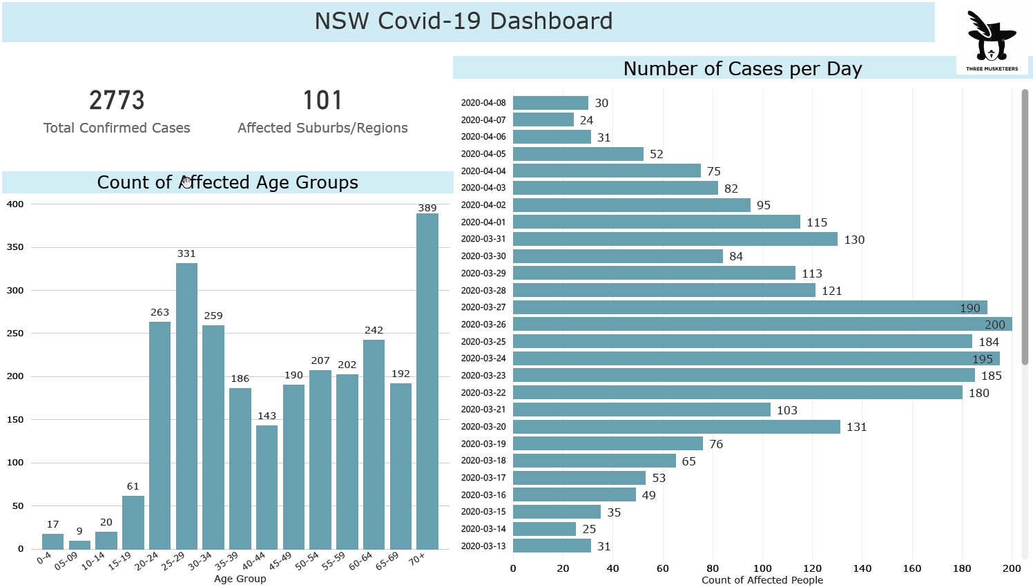

The dashboard depicts statistics of the affected groups that will be essential to monitor the pandemic and will be useful for the government to make informed decisions. The resource allocation process will come in handy to reduce the curve and help masses in need.

**Dashboard 2: Affected count - Suburb**

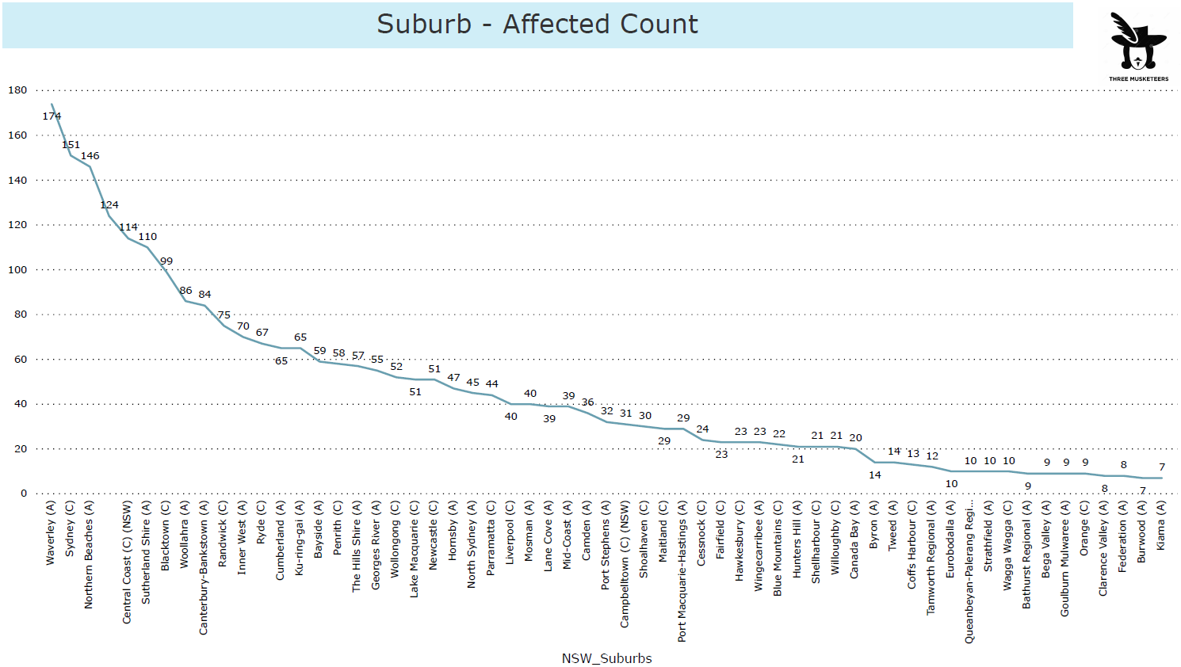

Suburbs will play a key role in identifying the number of cases and resource allocation. The data suggests that Waverley is the most affected region in NSW and necessary measures need to be taken.

**Dashboard 3: NSW Heatmap affected regions**

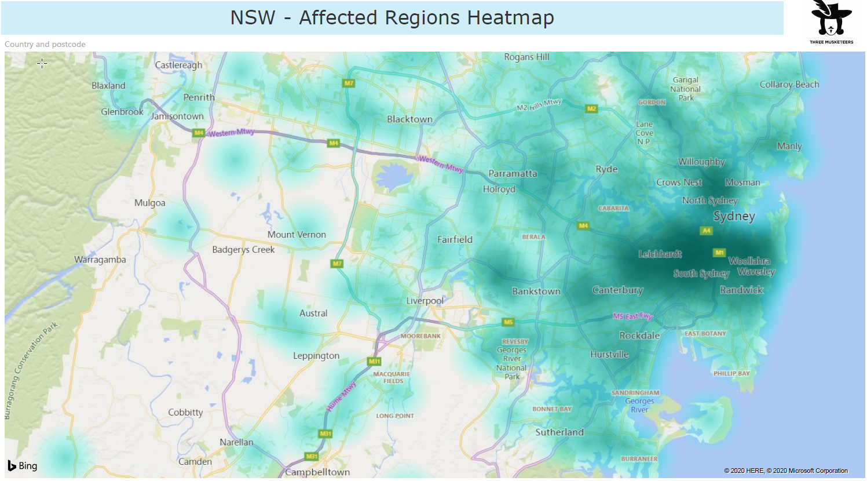Heatmaps are essential in identifying the most affected zones.

1. **Suggested Solution**

Our application is based on the key parameter which includes major symptoms, daily habits, medical history, age, location (indicating risk zone based on the number of covid19 cases) and travel. The region to include these factors are:

• Symptoms are the first way to find out whether someone is infected or not. But there are some cases too in which patients didn’t show the symptoms. So, to track those cases we are tracking possible areas that a patient has traveled within 5 days before showing major symptoms.

• This virus primarily impacts those people whose immunity has already been compromised, so to track this possibility we will look after the patient’s medical history of a major illness or any possible chronic diseases.

• Activities like smoking, drinking can possibly cause to weaken the immune system or lungs. Thus, these patients could be one of the targets of this virus so we have included habits in our parameter.

• This virus could be transmitted locally or internationally. So, to track those factors we have included location and travels made by the patients 5 days before showing major symptoms.

• The reason to count 5 days travel location is because, though the virus shows its symptoms in between 2-14 days, in a large population these are replicated in a 5 day time period.

**Guardian App:** This application is our proposed solution to handle the challenge. This app mainly collects personal and health-related data from patients and calculate the probability of them being currently infected with the coronavirus.

Step1: First the application will collect details like current symptoms, habits, age, and major visited public places in the past 5 days from the patient. After completing the form as the patient submits the query form it leads to few steps that run in the background.

Step2: Based on the details provided our application will access the medical history of patients and request details about major illness or current health status of the patient.

Step3: As all the data we collected are nominal. We process that data and grade each key parameter with numerical value considering each key parameter as a factor that shows the possibility of infection. The numerical value will range in one of the class from 0-10 for minor to major symptoms, 0-10 for medical history and current health status, 0-5 for habits responsible to weaken the immunity, 0-10 for living area considering possible local transfers (will access current infected count based on suburb or postal code from government collected data) and 0-5 for the age group. After this we will pass this pre-processed data to the Machine Learning model (which has already been trained in similar data, currently not ready, but can be done in collaboration with data governing entities i.e. the government) and predict the probability of a patient currently infected with the coronavirus.

Step4: The probability being higher than 85% will submit the collected data to the federal government / council for the government to take further measures.

Step5: If the probability ranges from 50% to 85% then Guardian will recommend the patient to contact GP’s and follow suggested instructions respectively.

Step6: The probability below 50% will suggest the personnel for a home Quarantine , rest, maintaining a proper diet, and taking general medications if required.

Changes required on federal government side to handle the problem efficiently (based on Guardian) are as:

• Federal government should operate at maximum council level or postal area level so that they can target as many people as possible in short period of time.

• It should be a collaborative process between different bodies of the government that will handle the cases with the highest probability of infection and balance the load of patients within the suburb and state level.

• As the government will be notified, medical services can transfer patients from to hospitals having the least number of cases.

• As we have collected data related to patients’ possible public place travel within 5 days, their international travel details, will be helpful for the government to track the possible spread of this disease locally or through international travel.

• In addition to that government can track possibly close friends and family members who might have come across to the patient before symptoms showed up and take proper actions (Which government is currently doing).

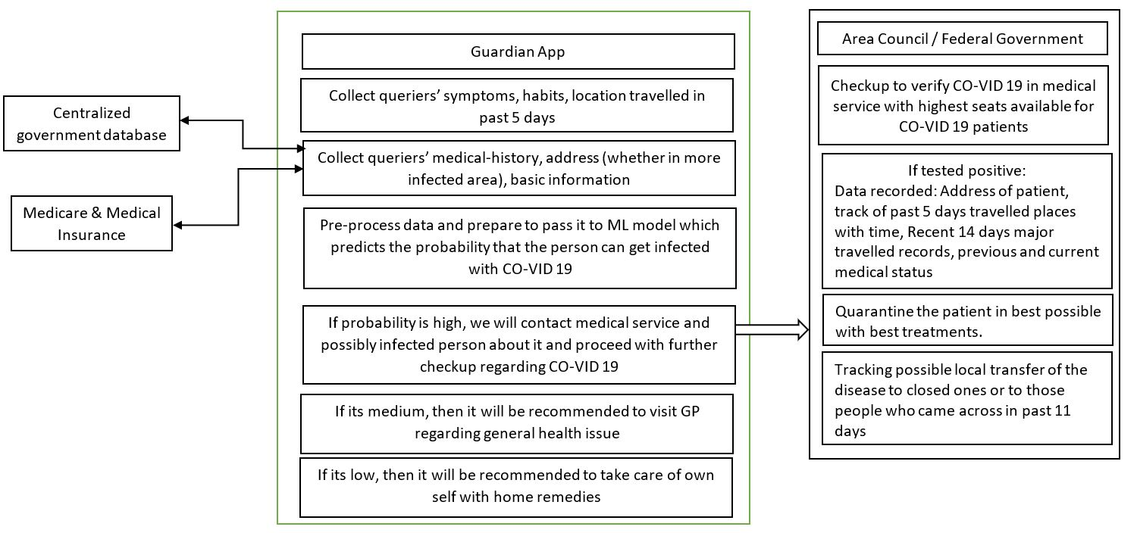

1. **UI design of the idea (website)**

The Guardian website (<https://emu-cod-35nr.squarespace.com/>) is a mobile responsive website, no special installation it can either be accessed through the URL directly or through the government application or the website embedded in. The application has two parts, the first part where users can ensure if they have any possibility of getting affected by COVID-19. No special logins or registrations required for users to check for their symptoms. The details entered by the users are stored on the server and the symptoms selected will be used as a test case in front of the algorithm trained based on the parameters in the datasets (data collection from different sources).

Once the user enters the details and checks for the symptoms the algorithm gives a detailed result based on the information provided by the user. The user information along with the location will be stored for further analysis (such as location wise status and prediction on the collected data). The second part includes the medical professional to login to the application.

**Medical Professional login**:

This is a dedicated login for all the medical professionals which has a detailed list of symptoms including patients recent international or domestic travel and medical history (medical conditions like diabetes, cancer, etc). This helps the medical professional to prioritise the patients based on how severe the case is based on the symptoms and patients medical history. Prioritising the location and the individuals affected will help the legal authorities to disperse medical resources and staff accordingly.

1. **Advantages of your idea**

* This will help all the users to ensure their risk of getting affected just by checking for symptoms by staying indoors, which plays a major role in avoiding the risk of COVID-19
* Maps in the application allows the users to check the areas affected with highest number of cases which can be avoided if needed to travel
* Infographics on the website will give all the users much detailed information on how to protect yourself and others while going outdoors
* Based on the users travel data it will be much easier to identify the other potential affected users who were in contact with the infected individuals, this will slow the spread of COVID-19
* The algorithm used is trained on the maximum available parameters which provides more accuracy when compared to humans, patients here can be identified more accurately and quickly
* “One app for all” intention will create less chaos among users, medical professionals and government officials as all the necessary information is available on the same app.

**Potential Difficulties**

* Need access to users critical data which may include some personal information
* Data from the hospitals if the user has any previous medical history
* Complexity on the data integration and data cleansing part as it will include data coming from several data sources with different data formats